Introduction:
For this demonstration, there are 5 parts, with the goal to take a picture of a sequence of three colored blocks and sorting them using a robotic arm into various bins based on color. To do this, an Arduino code is used to take images using an Arducam connected to the Arduino UNO board, a MATLAB code is used to process these images and detect color patterns, followed by another Arduino code to receive the sequence from the MATLAB code and sort the blocks with the robotic arm. This guide will explain every step, from taking images, to calibrating the robot arm.
Steps Overview:
- Take image using Arducam and Arduino program, Arducam host
- Upload robotic arm program to Arduino, no external power supply connected
- Use image in MATLAB program to send sequence to Arduino board, selecting the correct COM port for the Arduino
- Disconnect Arduino from computer, and connect external power supply to Arduino
- Reset Arduino, and allow it to sort
Part 1: Arduino UNO R3 Pinout for Arducam
To wire the Arducam to the Arduino, follow this pinout below:
Arducam Pins | Arduino UNO R3
CS | 7
MOSI | 11
MISO | 12
SCK | 13
GND | GND
VCC | 5V (Must be 5V)
SDA | A4
SCL | A5

Part 2: Image capture using Arducam
In order to take pictures using this camera, a specific program must be loaded onto the Arduino UNO, as well as a specific program that connects to the Arducam.

This YouTube video explains connecting to the camera very well.
Arducam Mini 2MP SPI Camera Module for Arduino Tutorial

This Website has the download for the Arduino Library.
GitHub - ArduCAM/Arduino: This is ArduCAM library for Arduino boards · GitHub

The correct program will look like this:
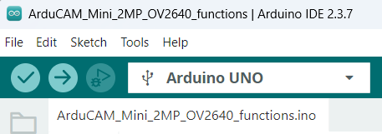
Figure 1: Arducam code
NOTE: Must change the baud rate in the program.
Line 42:
#if defined(__SAM3X8E__)
Wire1.begin();
Serial.begin(115200);
#else
Wire.begin();
Serial.begin(921600); Serial.begin(115200);
Correct code:
#if defined(__SAM3X8E__)
Wire1.begin();
Serial.begin(115200);
#else
Wire.begin();
Serial.begin(115200);
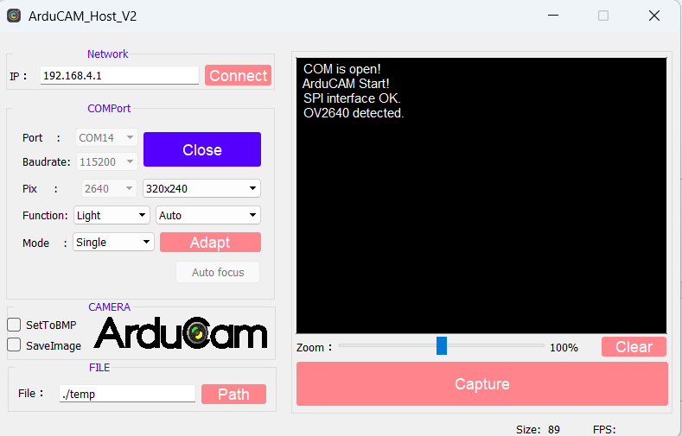
Figure 2: Arducam Host
Program should look similar to this with a different port.
Note: Must change baud rate in program to 115200.
After capturing image, save to folder with MATLAB file and rename to filename found in MATLAB script.
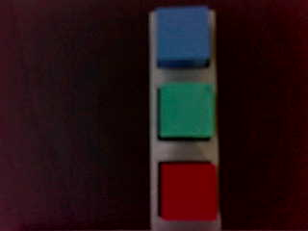
Figure 3: Example image for Arducam
The image above is a good example of how the blocks are arranged and how the image should appear. The sequence should be read top to bottom.

Part 3: MATLAB image processing
The next step is to use the MATLAB code to read the image, and process what the sequence is and send that to the Arduino program that controls the robot arm. The code for the robot arm is found in the next section, which must be uploaded to the robot before running the MATLAB code to have successful communication.
The code for MATLAB has many sections, so each section header will be explained now.
%% Image Capture via filename or webcamera
In this section, the image can either come from a file from an Arducam image, or from a connected webcam. When running this code, the name of the file must be changed to match the appropriate file from the picture taken.
%% Block Detection

Utilizes HSV to create certain cutoff values to detect what is a colored block and what is not a colored block. From this, a binary mask is created where the parts of a block are each set to 1, while everything else is set to 0.
Figure 4: Block detection
%% Color Detection
From each area of 1 value, the HSV values are measured, and then each pixel is classified as a blue, green, or red pixel and added to that count. Whichever counter has the highest value will determine the color of that block.
Figure 5: Color detection
%% Create sequence and print colors
After detecting the sequence, the color order will be printed with the appropriate sequence. All available ports will appear, allowing the user to time the associated index on the left to choose the port connected to the Arduino board. Typing 0 will cancel the program to make sure it cannot get stuck. In this section, the Arduino Serial Monitor must not be open as MATLAB requires this to connect to the board. After selecting the correct port, the sequence will be sent to the Arduino UNO.
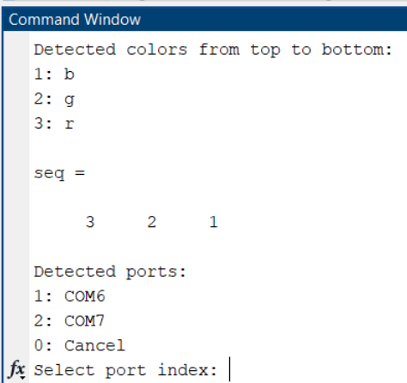
Figure 6: MATLAB command window for port selection

At this point, the MATLAB code is finished, and the robot is ready to sort. If the code is picking up shapes that are not the blocks, the HSV values must be tweaked to make sure the background is not too similar to the blocks. If the blocks are not being seen, then the HSV values must be changed to allow a wider range.

Part 4: Robot Arm Calibration
This part requires the most effort, as for each robot the values will be slightly different for the calibration. To start, the robot must be set appropriately with the jig, in a way that makes sure the jig is in line with the robot and as close to the base as possible.
Next, open the code called “RobotArmCalibration”, which allows a simple code that will set the location based on the values given, allowing a quick way to test new values. For each position, such as grabbing each block and placing each block, these values must be recorded and updated in the Arduino code “RobotArm_Pick_And_Place_MATLAB”.
Note: Never have external power supply or cable to computer connected at the same time. Power switch must be used to allow external power.
The next images will display how the values correspond to the arm movement.
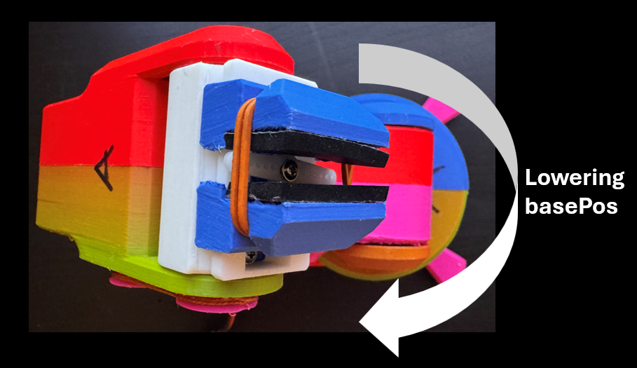
Figure 7: Base Position
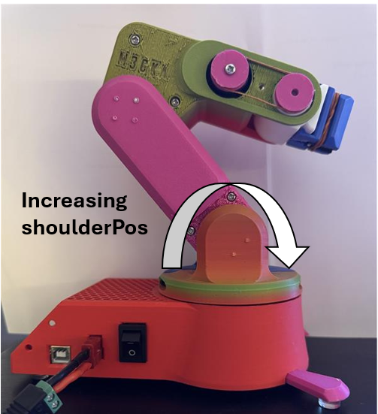
Figure 8: Shoulder Position
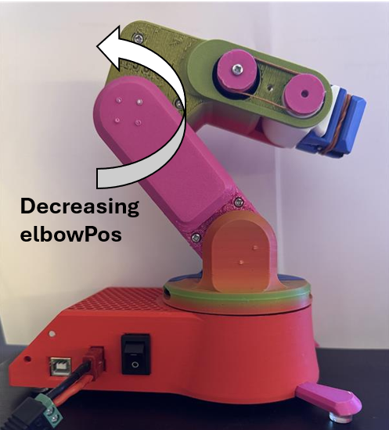
Figure 9: Elbow Position
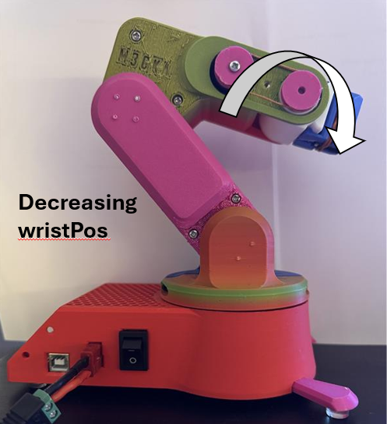
Figure 10: Wrist Position
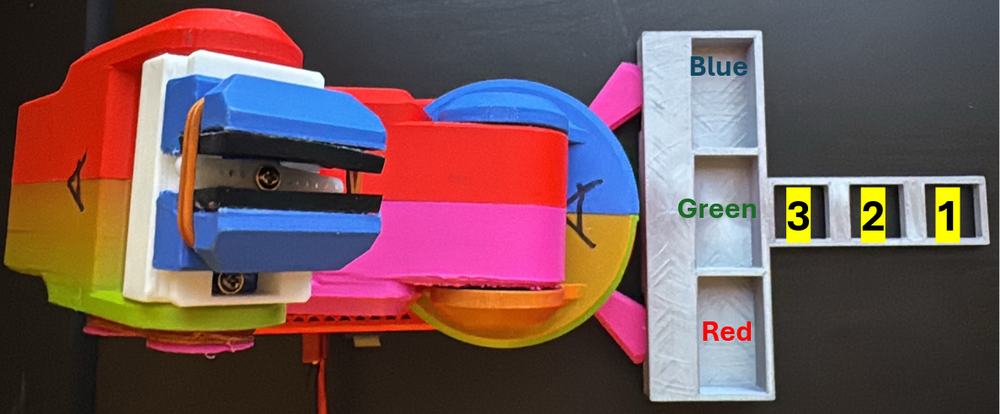
Figure 11: Jig location
Box 1 will be the first block grabbed, followed by box 2, and finally box 3.
The gripper should not need to be calibrated, the given values should work.
After calibrating and saving each of the variables, the code should be able to run a full sorting procedure.
Part 5: Robot Arm Sorting
After calibrating the arm, it is ready to receive data from the MATLAB code. Connect the robot to the computer, without the eternal power supply. Run the MATLAB code, and once it has sent to the robot, disconnect the Arduino from the computer. Connect the external power supply to the robot, and set the voltage to around 6 volts. Flip the power switch, and then press the reset button on the Arduino, and the robot should sort the blocks.

